**LAB # 03**



**Statement Purpose:**

To take a closer look at the client side of DNS. While execution of a DNS query, much can go on “under the covers,” invisible to the DNS clients, as the hierarchical DNS servers communicate with each other to either recursively or iteratively resolve the client’s DNS query.

**Activity outcomes:**

• Students will be able to better understand the working of DNS

**Instructor Note:**

• In this first Wireshark lab, you’ll captures some DNS packets using wireshark and make some

observations on them.

**1) StageJ(Journey)**

**Introduction**

nslookup

In this lab, we’ll make extensive use of the *nslookup* tool, which is available in most

Linux/Unix and Microsoft platforms today. To run *nslookup* in Linux/Unix, you just type the *nslookup* command on the command line. To run it in Windows, open the Command Prompt and run *nslookup* on the command line.

In it is most basic operation, *nslookup* tool allows the host running the tool to query any

specified DNS server for a DNS record. The queried DNS server can be a root DNS server, a top-level-domain DNS server, an authoritative DNS server, or an intermediate DNS server (see the textbook for definitions of these terms). To accomplish this task, *nslookup* sends a DNS query to the specified DNS server, receives a DNS reply from that same DNS server, and displays the result.

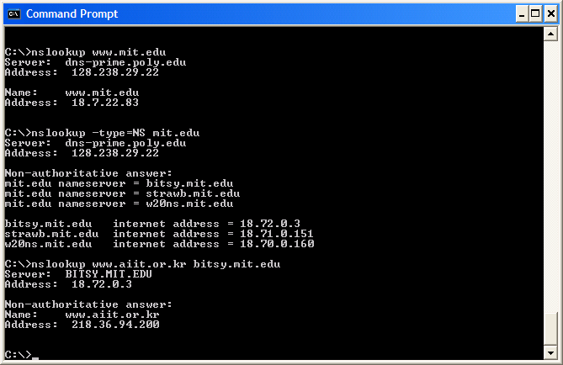

The above screenshot shows the results of three independent *nslookup* commands (displayed in the Windows Command Prompt). In this example, the client host is located on the campus of Polytechnic University in Brooklyn, where the default local DNS server is dns-prime.poly.edu. When running *nslookup*, if no DNS server is specified, then *nslookup* sends the query to the default DNS server, which in this case is dns-prime.poly.edu. Consider the first command:

nslookup [www.mit.edu](http://www.mit.edu)

In words, this command is saying “please send me the IP address for the host [www.mit.ed](http://www.mit.edu)u”. As shown in the screenshot, the response from this command provides two pieces of information: (1) the name and IP address of the DNS server that provides the answer; and (2) the answer itself, which is the host name and IP address of [www.mit.ed](http://www.mit.edu)u. Although the response came from the local DNS server at Polytechnic University, it is quite possible that this local DNS server iteratively contacted several other DNS servers to get the answer, as described in Section 2.5 of the textbook.

Now consider the second command:

nslookup –type=NS mit.edu

In this example, we have provided the option “-type=NS” and the domain “mit.edu”. This causes *nslookup* to send a query for a type-NS record to the default local DNS server. In words, the query is saying, “please send me the host names of the authoritative DNS for mit.edu”. (When the –type option is not used, *nslookup* uses the default, which is to query for type A records.) The answer, displayed in the above screenshot, first indicates the DNS server that is providing the answer (which is the default local DNS server) along with three MIT nameservers. Each of these servers is indeed an authoritative DNS server for the hosts on the MIT campus. However, *nslookup* also indicates that the answer is “non-authoritative,” meaning that this answer came from the cache of some server rather than from an authoritative MIT DNS server. Finally, the answer also includes the IP addresses of the authoritative DNS servers at MIT. (Even though the type-NS query generated by *nslookup* did not explicitly ask for the IP addresses, the local DNS server returned these “for free” and *nslookup* displays the result.)

Now finally consider the third command:

nslookup [www.aiit.or.kr](http://www.aiit.or.kr) bitsy.mit.edu

In this example, we indicate that we want to the query sent to the DNS server bitsy.mit.edu rather than to the default DNS server (dns-prime.poly.edu). Thus, the query and reply transaction takes place directly between our querying host and bitsy.mit.edu. In this example, the DNS server bitsy.mit.edu provides the IP address of the host [www.aiit.or.kr,](http://www.aiit.or.kr) which is a web server at the Advanced Institute of Information Technology (in Korea).

Now that we have gone through a few illustrative examples, you are perhaps wondering about the general syntax of *nslookup* commands. The syntax is:

nslookup –option1 –option2 host-to-find dns-server

In general, *nslookup* can be run with zero, one, two or more options. And as we have seen in the above examples, the dns-server is optional as well; if it is not supplied, the query is sent to the default local DNS server.

**2) Stage a1 (apply) Lab Activities: Activity 1:**

Now that we have provided an overview of *nslookup*, it is time for you to test drive it yourself. Do the following (and write down the results):

6. Run *nslookup* to obtain the IP address of a Web server in Asia. What is the IP address of that server?

7. Run *nslookup* to determine the authoritative DNS servers for a university in Europe.

8. Run *nslookup* so that one of the DNS servers obtained in Question 2 is queried for the mail

servers for Yahoo! mail. What is its IP address?

ipconfig

*ipconfig* (for Windows) and *ifconfig* (for Linux/Unix) are among the most useful little utilities in your

host, especially for debugging network issues. Here we’ll only describe *ipconfig*, although the

Linux/Unix *ifconfig* is very similar. *ipconfig* can be used to show your current TCP/IP information, including your address, DNS server addresses, adapter type and so on. For example, if you all this information about your host simply by entering

ipconfig \all

into the Command Prompt, as shown in the following screenshot.

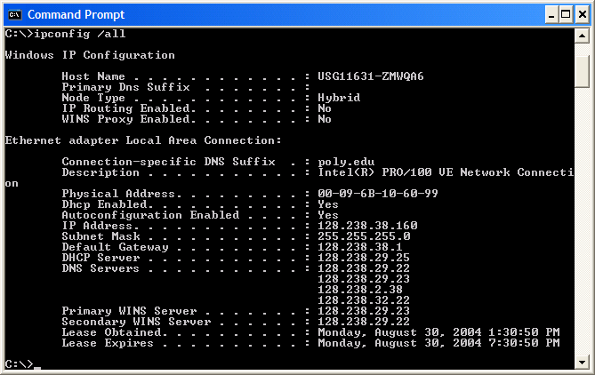

*ipconfig* is also very useful for managing the DNS information stored in your host. In Section 2.5 we learned that a host can cache DNS records it recently obtained. To see these cached records, after the prompt C:\> provide the following command:

ipconfig /displaydns

Each entry shows the remaining Time to Live (TTL) in seconds. To clear the cache, enter ipconfig /flushdns

Flushing the DNS cache clears all entries and reloads the entries from the hosts file

**Activity 2:**

Now that we are familiar with *nslookup* and *ipconfig*, we’re ready to get down to some serious

business. Let’s first capture the DNS packets that are generated by ordinary Web-surfing activity.

* Use *ipconfig* to empty the DNS cache in your host.
* Open your browser and empty your browser cache. (With Internet Explorer, go to Tools menu and select Internet Options; then in the General tab select Delete Files.)
* Open Wireshark and enter “ip.addr == your_IP_address” into the filter, where you obtain your_IP_address with ipconfig. This filter removes all packets that neither originate nor are destined to your host.
* Start packet capture in Wireshark.
* With your browser, visit the Web page: <http://www.ietf.org>
* Stop packet capture.

If you are unable to run Wireshark on a live network connection, you can download a packet trace file that was captured while following the steps above on one of the author’s computers3. Answer the following questions. Whenever possible, when answering a question below, you should hand in a printout of the packet(s) within the trace that you used to answer the question asked. Annotate the printout4 to explain your answer. To print a packet, use *File->Print*, choose *Selected packet only*, choose *Packet summary line,* and select the minimum amount of packet detail that you need to answer the question.

1. Locate the DNS query and response messages. Are then sent over UDP or TCP?

2. What is the destination port for the DNS query message? What is the source port of DNS

response message?

3. To what IP address is the DNS query message sent? Use ipconfig to determine the IP address

of your local DNS server. Are these two IP addresses the same?

4. Examine the DNS query message. What “Type” of DNS query is it? Does the query message contain any “answers”?

5. Examine the DNS response message. How many “answers” are provided? What do each of

these answers contain?

6. Consider the subsequent TCP SYN packet sent by your host. Does the destination IP address of the SYN packet correspond to any of the IP addresses provided in the DNS response message?

7. This web page contains images. Before retrieving each image, does your host issue new DNS

queries?

**Activity 3:**

Now let’s play with *nslookup*5.

* Start packet capture.
* Do an *nslookup* on [www.mit.edu](http://www.mit.edu)
* Stop packet capture.

You should get a trace that looks something like the following:

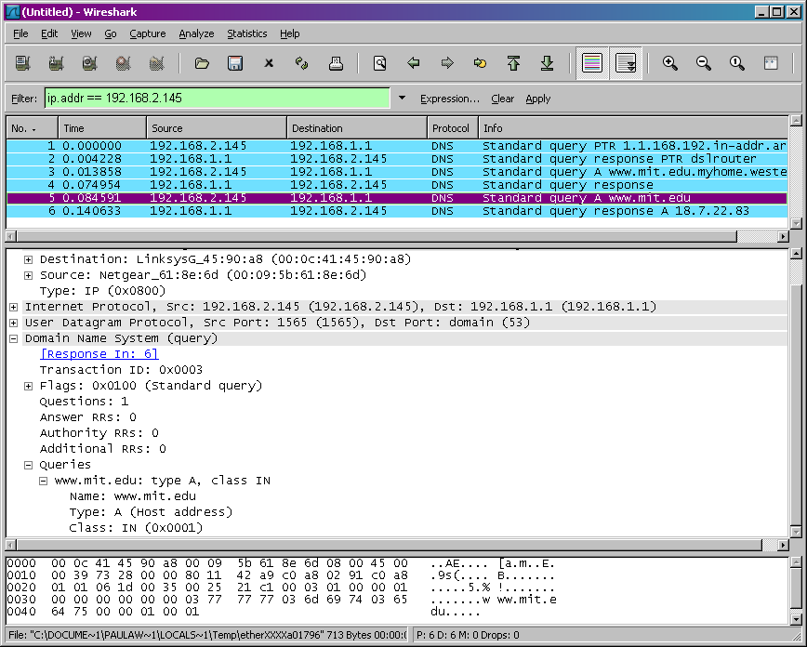

We see from the above screenshot that *nslookup* actually sent three DNS queries and received three DNS responses. For the purpose of this assignment, in answering the following questions, ignore the first two sets of queries/responses, as they are specific to *nslookup* and are not normally generated by standard Internet applications. You should instead focus on the last query and response messages.

1. What is the destination port for the DNS query message? What is the source port of DNS

response message?

2. To what IP address is the DNS query message sent? Is this the IP address of your default local

DNS server?

3. Examine the DNS query message. What “Type” of DNS query is it? Does the query message contain any “answers”?

4. Examine the DNS response message. How many “answers” are provided? What do each of

these answers contain?

5. Provide a screenshot.

**Activity 4:**

Now repeat the previous experiment, but instead issue the command:

nslookup –type=NS mit.edu

Answer the following questions6 :

1. To what IP address is the DNS query message sent? Is this the IP address of your default local DNS server?

2. Examine the DNS query message. What “Type” of DNS query is it? Does the query message contain any “answers”?

3. Examine the DNS response message. What MIT nameservers does the response message provide? Does this response message also provide the IP addresses of the MIT namesers?

4. Provide a screenshot.

**3) Stage v (verify) Home Activities: Activity 1:**

Repeat the previous experiment, but instead issue the command:

nslookup [www.aiit.or.kr](http://www.aiit.or.kr) bitsy.mit.edu

Answer the following questions7:

* To what IP address is the DNS query message sent? Is this the IP address of your default local

DNS server? If not, what does the IP address correspond to?

* Examine the DNS query message. What “Type” of DNS query is it? Does the query message contain any “answers”?
* Examine the DNS response message. How many “answers” are provided? What does each of

these answers contain?

• Provide a screenshot.